}

1. **PART I**

| **1. Personal Background** |
| --- |
| Below is a table in which you must complete the requested information. |

| Name of Members | **Kevin Bustos - Antonio Martínez - Freddy Cardenas - Mario Silva - Luis Mardones** |
| --- | --- |
| Rut | **19.812.719-1 / 21.592.681-8/21.452.954-8/ 20.450.034-7 / 18.185.882-6** |
| Career | **Computer Engineering** |
| Headquarters | **Puente Alto** |

| **2. APT Project Description** |
| --- |
| In the description, you should briefly describe the name of your APT project and the graduate profile competencies you will implement. If your program defines performance areas, also mention which performance areas the project is linked to. |

| Topic | **LogisticFour – Inventory Manager** |
| --- | --- |
| Area(s) of performance(s) (Optional) | **Software development**  **IT project management**  **Information management**  **Technological infrastructure and support** |
| Competencies of the graduate profile | **Requirements gathering and analysis**  **Computer systems development and integration**  **Information and database management**  **Computer systems security**  **Software quality assurance**  **IT project management**  **Technical user support services**  **Problem resolution**  **Teamwork**  **Innovation and continuous learning** |

| **3. APT Project Foundation** |
| --- |
| Below are various fields that you must complete with the requested information. This section aims to help you describe your project in detail and justify its relevance and suitability. |

| Relevance of the APT project | Distribuidora Andes Ltda. faces significant challenges in inventory management due to the use of disparate Excel spreadsheets. This has led to errors in records, loss of expired products, delays in supplies, and a lack of traceability in warehouse and branch operations.  In the field of Computer Engineering, these problems are very common, and solving them through a centralized system constitutes a significant contribution to optimizing business processes. The development of LogisticFour will allow the company to apply skills specific to the program and provide technological solutions with a direct impact on efficiency, cost reduction, and improved decision-making. |
| --- | --- |
| APT Project Description | LogisticFour will be a technological solution composed of:  A Web-based Inventory Management System, accessible from any browser, allowing real-time monitoring of product inflows, outflows, location, and status.  A Desktop Application, designed for centralized system management, with greater administrative control, security, and advanced features for managers or users working from fixed workstations.  Main Modules:  Products: Records, categories, batches, and expiration dates.  Suppliers: Purchase and associated sales history.  Warehouses and Branches: Stock control by location.  Users: Differentiated roles and permissions (administrator, warehouse manager, auditor).  Reports: Minimum stock alerts, product rotation, and loss control.  Transaction history: Inflows, outflows, transfers, and returns.  The Desktop App will function as an administrative control tool and audit support, offering:  Advanced management of financial and logistics reports.  User control and permission assignment.  Real-time synchronization with the web system's database.  Greater stability in internal company environments (headquarters).  This combination ensures flexibility (usage from the web) and corporate control (from the desktop application). |
| Relevance of the project to the graduate profile | The inclusion of a desktop application further strengthens the program's competencies, as it:  Extends the development and integration of computer systems to hybrid environments (web and desktop).  Requires greater work in information and database management, ensuring consistency between both environments.  Boosts IT security, as the desktop app will have critical control and auditing functions. |
| Relationship with professional interests | The LogisticFour project reflects our professional interests in software development and business process optimization. As a team, we focused on creating a solution that optimizes inventory management using web and desktop technologies, enabling the integration of hybrid systems. This approach allows us to apply our skills in programming, databases, cybersecurity, and project management—key areas of our Computer Engineering training. It also gives us the opportunity to work on a project with a real impact on a company's operational efficiency, which will significantly contribute to our professional development. |
| Feasibility of developing the APT Project | The development of LogisticFour is entirely feasible within the available timeframe, as the semester is long enough for the team to carry out the planning, development, and implementation phases of the system. The hours allocated for the course will allow tasks to be effectively distributed among team members, and the use of accessible tools such as Django, JavaScript, and SQL databases will facilitate the development process.  External factors that facilitate development include access to academic and technical resources provided by the institution, as well as the possibility of receiving support from faculty. However, some factors that could hinder development include scheduling coordination among team members and potential compatibility issues between web and desktop environments. To mitigate these obstacles, the team plans to divide the work into phases and prioritize the system's most critical functionalities, ensuring that each part is up and running in time for partial deliveries. |

1. **PART II**

| **4. Objectives** |
| --- |
| In this section, you must define the general and specific objectives of the APT Project. It is important to clarify that the objectives should be stated clearly, concisely, and without further explanation; that is, they should be self-explanatory. It is suggested that they be written using an infinitive verb, as this requires specifying specific actions. |

| General objective | *Develop LogisticFour, an integrated solution comprised of a web-based system and a desktop application, that optimizes inventory management at Distribuidora Andes Ltda., ensuring real-time control, traceability, and automated reporting.* |
| --- | --- |
| Specific objectives | 1. *Determine and document the functional and non-functional requirements of the system (web and desktop).* 2. *Design the software architecture, considering synchronization between the web and desktop applications.* 3. *Implement the main modules for products, suppliers, warehouses, and users in both environments.* 4. *Develop the desktop application with administrative control and auditing functions.* 5. *Integrate real-time synchronization mechanisms between the web system and the desktop application.* 6. *Run functional, unit, and integration tests in both environments.* 7. *Document the system, including user, technical, and installation manuals.* |

| **5. Methodology** |
| --- |
| In the following section, you must describe the methodology, specific to your discipline, that you will use to complete the APT project described above, including the stages and working methods. |

| Description of the Methodology |
| --- |
| *The project will be developed using the traditional Waterfall Methodology, which consists of a sequential and structured process, where each phase must be completed before moving on to the next. This methodology is appropriate because the system requirements are clearly defined and no significant changes are expected during development.* |

| **6. Evidence** |
| --- |
| Next, describe what evidence will be assessed in the progress report and the final report for your APT project. This evidence should be agreed upon with your instructor. Evidence refers to the products developed during the project and whose purpose is to visualize or document how the work was implemented. |

| **Type of evidence**  **(progress or final)** | **Name of the evidence** | **Description** | **Justification** |
| --- | --- | --- | --- |
| **Progress** | **Requirements Sheet**   |  | | --- | | **Requirements document (web + desktop)** | **Clearly defines what needs to be developed** |
| **Progress** | **Gantt Chart** | **Project schedule** | **Control and planning deadlines** |
| **Progress** | **ERS** | **Specification document** | **Justifies design and development** |

| **7. Work Plan** |
| --- |
| In the following table, define your APT Project planning according to the requirements. |

[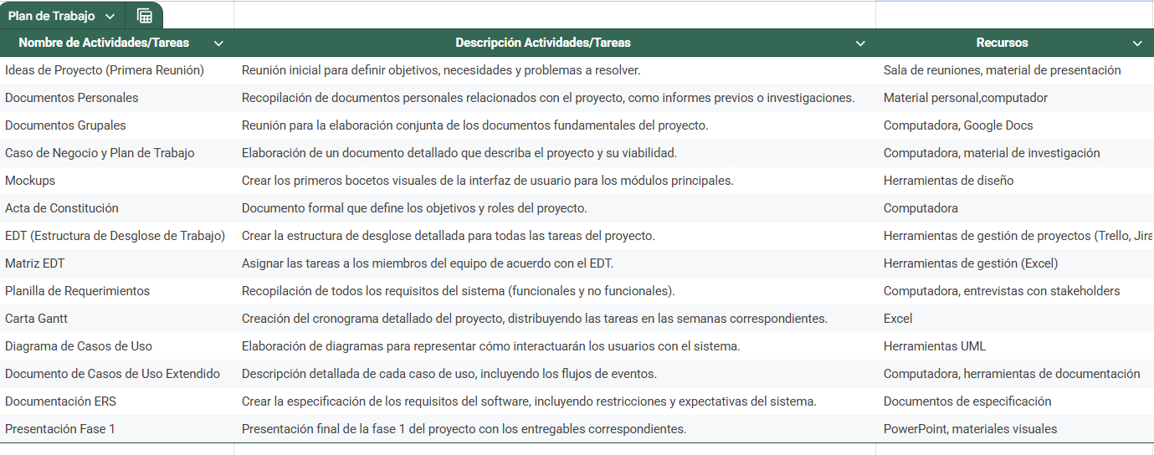](https://docs.google.com/spreadsheets/d/1uqRBjWfaNsCtG7Q_ih54UNtkGGmrn0RP7Wwjy35L5NM/edit?gid=0#gid=0)

| **8. Gantt chart** |
| --- |
| Find a Gantt chart format that suits you and organize the activities planned in the previous point, taking into account the period assigned for the development of your APT Project. You must maintain the academic period in the development of the three phases of the Degree Portfolio Course. |

[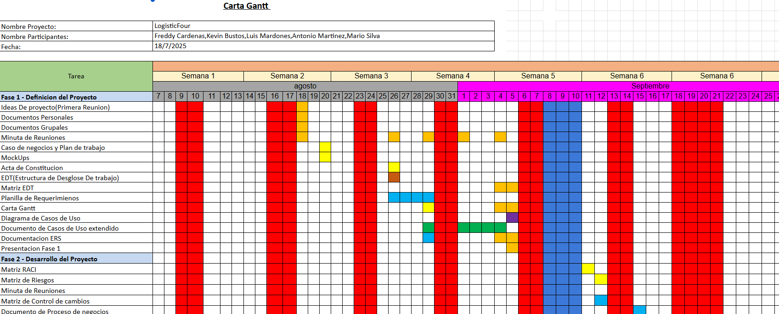](https://docs.google.com/spreadsheets/d/1JkeOZJzGwOvXaG7FHW4l6oiAcFCMuBSP/edit?gid=1562700785#gid=1562700785)